**Part 1: Ideation**

**Link to itch.io page:** <https://vonvonliu.itch.io/original-game-combat-corona>

1. **Game Roulette Theme**: Fashion Date (from recitation)

Wild Ideas:

* costume party
* picking out outfits for a normal date
* wacky clothing choices (animals, bathroom theme, nature)
* speed dating with costumes
* arranged marriage meeting wearing weird clothes
* Tinder date- pick an outfit
* outfit randomizer
* dress appropriately and pick out outfit for a family dinner
* dress up your pets for their date
* Project Runway date
* Dress up kids for a play date
* A date where you pick outfits together and get ratings for them
* Going to the mall to pick outfits for each other
* Design clothes for your own date
* Draw out designs and make clothes for other people’s dates

Final Sentence and Elevator Pitch:

* a 2D platform where the user is stuck in his/her dream, and in order to wake up, he/she must escape the monsters’ lairs by having dates with them and picking out the perfect outfit for them based on their requests which are in the form of a riddle
* Be thrown into a dream world through a game full of mysteries, monsters, and miniskirts.

1. **Other Ideas:**

* cooking simulation
* lots of animals interacting with each other
* zombie apocalypse
* vampires and werewolves
* built in puzzles
* crazy pigs vs Totoro
* number game puzzle
* (impose the constraint of: played at night)
* Pokemon Go at night (safer version)
* Night mode
* glow in the dark effect
* hide and seek
* Bunnicula
* “Goosebumps” made into a game

1. **What I Learned:**

During the ideation stage, I found that it was difficult to come up with ideas of games that have never been invented before; a lot of the things I was thinking about were based on what I have already seen. Therefore, some of the techniques like imposing constraints were even more important because they helped me to come up with more wild and unique ideas. It was also hard to think up non-repeating and less similar ideas.

**Part 2: Paper Prototyping**

1. **Paper Prototypes:**

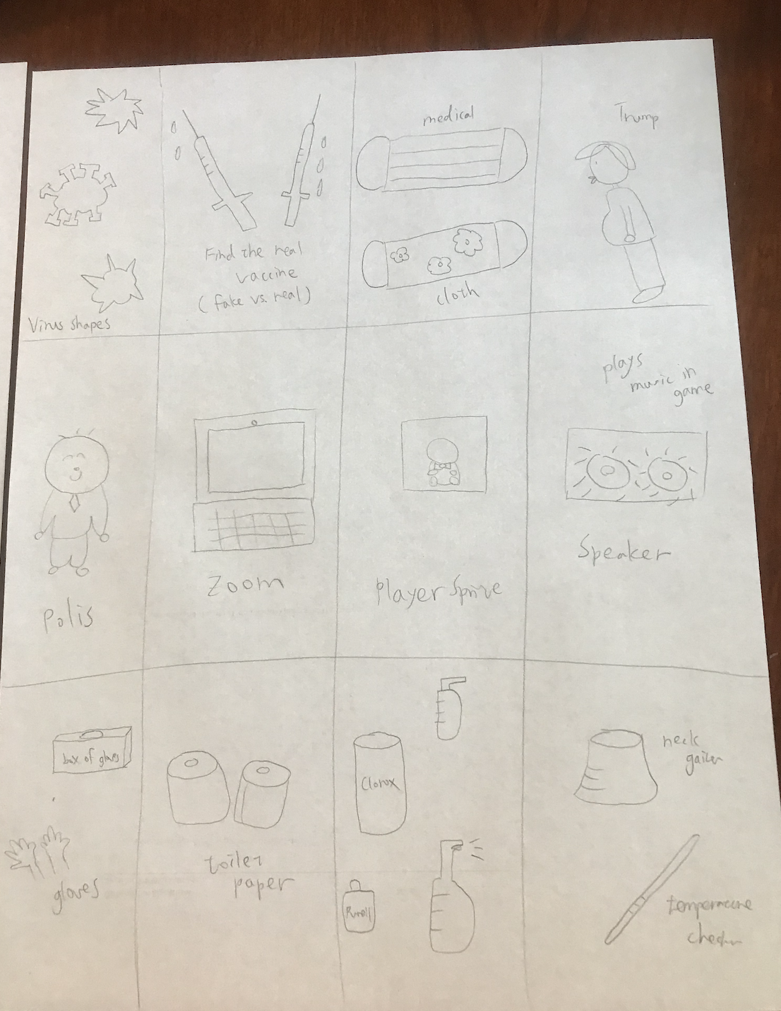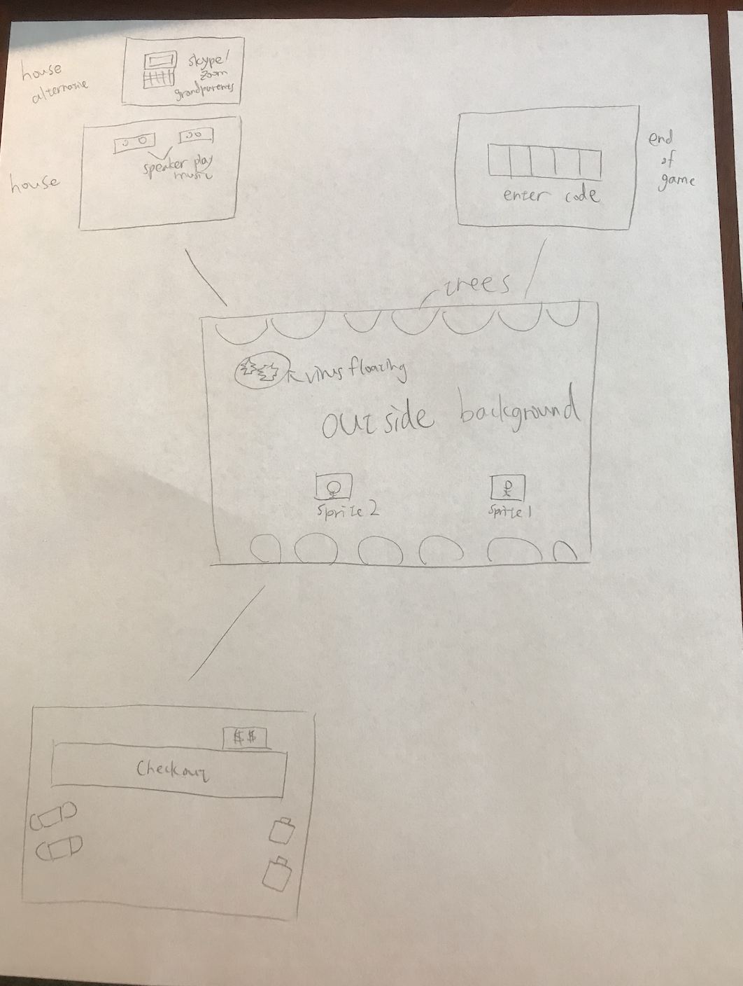

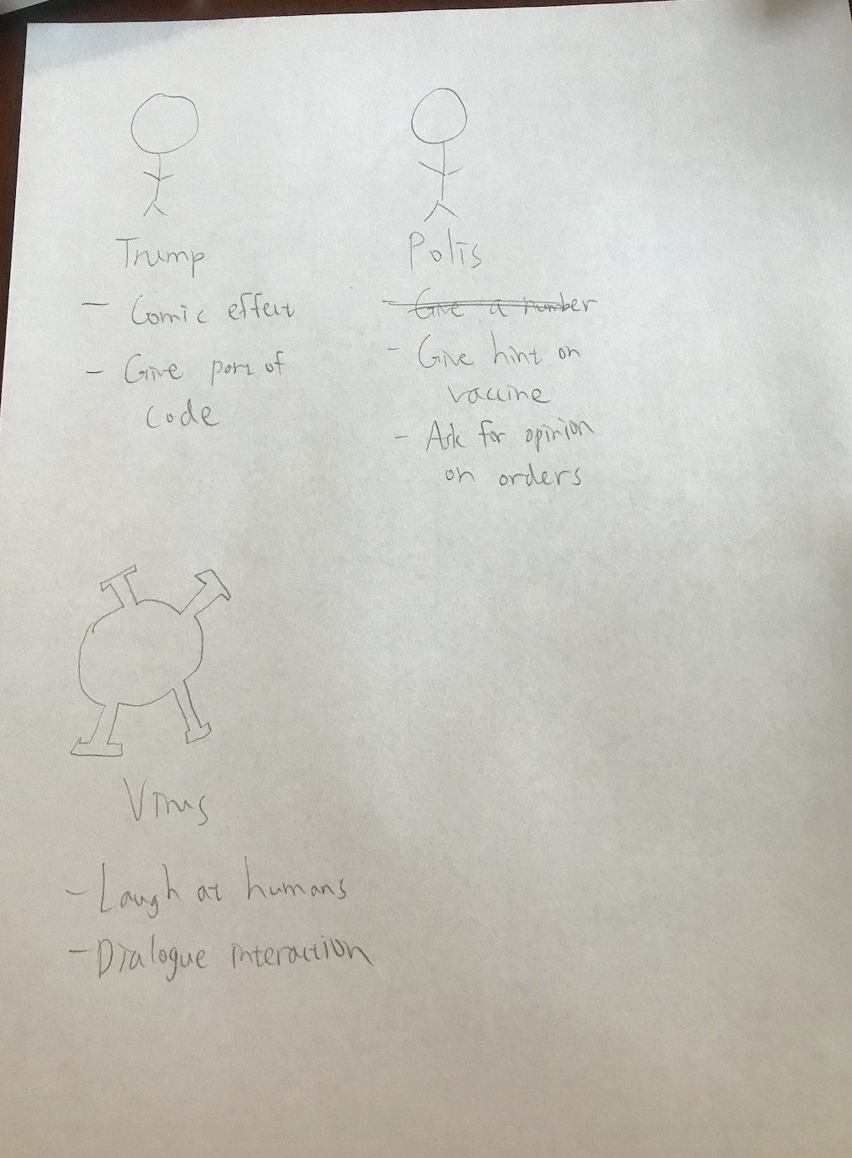

1. **What I Learned:**

At first I was thinking of doing prototypes based on a few of the different ideas I listed out above. However, I found out that it was easier to first narrow down to one more specific narrow idea and prototype based off of that because it is now more focused and not random. After I let my family look at and test my prototypes, I learned that I should have a couple more different settings to increase the game interactions. In addition, I got the idea of incorporating puzzles throughout the game to make it harder and more interactive/ fun. I also got to narrow down which designs I like during this prototyping stage.

**Part 3: Digital Prototyping**

1. **Digital Prototypes:**

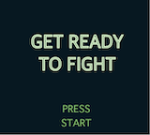 Screen testing (bad resoltion)

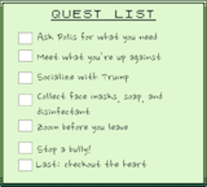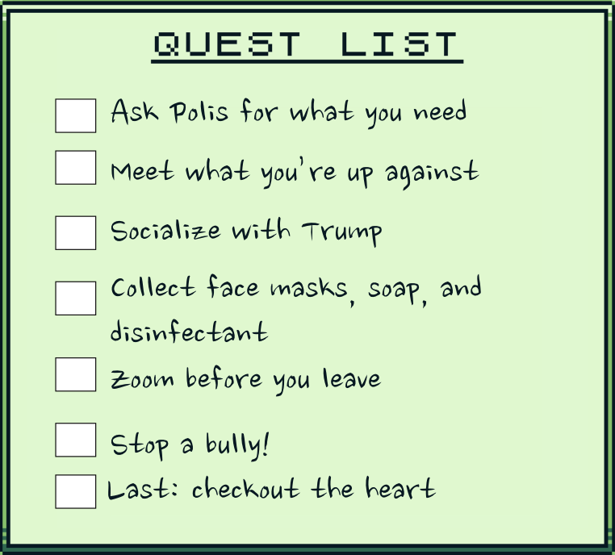Menu after size reduction

Trump sprite

1. **What I Learned:**

The idea is successful in that it is around five minutes or more of interaction, and there are several different components to the game. Although it has slightly similar concepts to the sample game, I also incorporated different sprites and backgrounds with different interactions between the actors. What was less successful was that after I made the sprites and tried putting them into the scenes, I noticed that the colors of the sprites oftentimes were the same as the background, so then parts of the sprite would disappear into the background. This became a really big problem that I was not sure how to fix besides constructing the sprites again. In addition, since I did not know how the colors we were allowed to use (the few different shades of green) should be used so that no parts would disappear, I couldn’t create sprties that were as well-made as the ones in the sample game. In the future, I can figure out a different way to make sprites and background to make them more visually appealing and clearer. Also, I can include a bigger variety of interactions to make the game even more interactive. What I learned about how my idea was perceived is that it is difficult to actualize all the things I wanted in the game, such as having an inventory and including more complex puzzles.

**Part 4: Final Game**

During the making of the final game, I learned that it actually takes quite a long time to create a decent game, even with a well-developed, easy to use tool like GB Studio. Making the sprites were extremely difficult because I did not want to pay for Adobe Photopshop and the sprites I made with Aesprite were less visually appealing, so I used some of the free assets from itch.io that other people have made (credits found on itch.io page of the game). To expand more on making the sprites, while using Aesprite, since it was the free version, I was not able to save the sprites I made, so I took screenshots then adjusted the size manually, which made them more pixelated. In addition, I made a different menu page through AdobeXD, but it was way too blurry for the game, so I kept the original one (the one I created is shown above). Furthermore, I could not figure out when the check boxes would be checked off of the quest list when certain actions were completed. Although I really wanted to implement that function, I never got to, Working through the game mechanics was also slightly hard to figure out at first because there were so many detials like how fast the characters moved and figuring out what was an appropriate speed and I didn’t know what to do with the different variables. However, the mechanics are actually very easy to use once I got familiar with them. After making this game, I realized how hard game design really is, especially when we have to create a totally unique, playable, intruiging game. Overall, working through this process was enjoyable and I learned a lot from it.